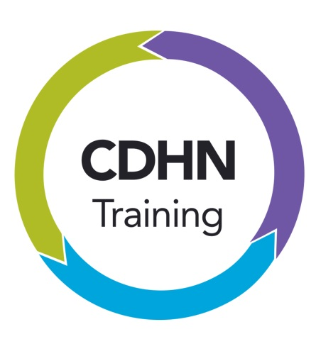
Community Development and Health Network (CDHN)

COMMUNITY HEALTH CHAMPIONS TRAINING
“Health for all will be achieved by people themselves. A well informed, well-motivated and actively participating community is a key element for the attainment of the common goal.” (World Health Organisation)
CDHN supports and promotes a community development approach to tackling health inequalities and encourages action on the social determinants of health. CDHN training is based on a community empowerment model and underpinned by the belief that everyone has the potential to implement change and have a positive impact on individual and community health.
Although the term ‘Community Health Champion’ is relatively new the idea that people can become leaders, educators, supporters and helpers around health issues in their community is not new. There are many roles that support this approach such as; community health workers, lay health workers, community development and health workers, peers support workers etc. There are other approaches that are based on broadly similar understanding of how community members can promote health, though not all of them are informed by an empowerment model.
NICE Guidance on Community Engagement recommends recruiting community members ‘to plan and deliver health promotion activities and help address the wider determinants of health’. They say, ‘health champions are individuals who possess the experience, enthusiasm and skills to encourage and support other individuals to engage in health promotion activities. They also ensure that the health issues facing communities remain high on the agenda of organisations that can effect change.’
CDHN identify this multi-dimensional approach as a key concept to the success of Community Health Champions.

‘Serious health inequalities do not arise by chance, and they cannot be simply attributed to genetic makeup, ‘bad’, unhealthy behaviour, or difficulties in access to medical care, important as those factors may be.’ (Marmot)
There is an abundance of literature and evidence identifying the causes of health inequalities and highlighting the need to address the social determinants of health. People need to be supported at an individual level to build their capacity and increase the control they have over the events that influence their lives and health. However, health inequalities mirror structural inequalities in society and so the challenge is to work for environmental, organisational and system change.
‘How do people (who have been ground down by unemployment, low wages, bad housing, poor diet etc) begin to participate in policy making and to look at their needs, not on solutions imposed from the outside?’(Jones, 1992)
Community empowerment builds from individual action and this approach embraces collective action. Create the conditions where people can make and sustain health changes and where they can be active participants and engage with people who are facing similar problems.
“Improving health literacy aims to influence not only individual lifestyle decisions about treatment and self-care, but also raise awareness of the determinants of health, and encourage individual and collective actions – at all levels of society- which may lead to a modification of these determinants.” (Making Life Better, 2014)

Community Empowerment as a Continuum

Key characteristics of Community Health Champions:
There is sufficient evidence internationally and nationally to demonstrate the positive impact of lay health workers and volunteers on tackling health issues
- Health Champions must be recruited from the communities in which they will work and be community based and community focused – communities may nominate or identify
- Health Champions have the potential to be a fantastic resource for public health. To maximise this potential the power dynamics need to be addressed
- Health Champions will adopt a social model of health approach and work with communities to identify and address the root causes of health inequalities
- Health Champions role will be proactive and engaging with local communities, community and voluntary groups and providers of services
- Health Champions will act as a voice for those most marginalised and effected by health inequalities
- Health Champions can, and will, work with individuals but the focus of their work should always be as part of the bigger picture
- Health Champions work will be underpinned by the values of community development
- This work will bring extra personal and social benefits for the Health Champion volunteers themselves
- Health Champions will need on-going support in their role. This should include on-going training and a networking element that facilitates peer support

The training will be underpinned by reflective practice.
Learning Objectives of Community Health Champion Training
- The training will ensure that participants understand the social model of health and how social determinants affect health both directly and indirectly
- Participants will be challenged to explore their personal values and to reflect on what qualities and resources they bring to their new role
- Participants will understand the values and principles of community development and its effectiveness in tackling health inequalities
- Participants will improve their health literacy
- Participants will gain an understanding into the benefits of working collaboratively
- Participants will feel confident to use their knowledge and life experience within the role

Role of CDHN
- Develop and deliver the Community Health Champions Training
- Articulate the policy context for the work of the Community Health Champion in NI
- Demonstrate the efficacy of an empowerment approach
- Support for organisations in the development of the Community Health Champions role

Cost and Accreditation
Community Health Champions is delivered over 2 days. It is accredited by the Open College Network (OCN) available at Levels 1 and 2.
COST: £150 per person + accreditation certificate cost £30per person.
All prices are inclusive of VAT and include materials and resources.

Other training options available.
Facilitation Skills for Community Health Champions is another course which includes Community Health Champions training and an additional training day (3 days) on Group Work Skills. This is also accredited by OCN and available at either levels 1 and 2.
COST: £215 per person + accreditation certificate cost £30 per person.
Skills for Volunteers – Improving health and well-being is a one day course to help volunteers understand the factors which affect health and well-being and be able to demonstrate effective ways to support their communities on issues of health and well-being. This is accredited by OCN at Level 1.
COST: £78 per person + accreditation certificate cost £30 per person

